

SRI LANKA INSTITUTE OF INFORMATION TECHNOLOGY

[**Enterprise Standards and Best Practices for IT Infrastructure**](http://courseweb.sliit.lk/course/view.php?id=137)

**4th Year 2nd Semester 2014**

Name: L.A.C.Dissanayake.

SLIIT ID: IT13147006

Group Number:

Practical Session: WD

Practical Number : Lab 04

Date of Submission: 16/08/2016

Date of Evaluation : _____________________

Evaluators Signature : _____________________

Introduction

Hypervisors run directly on the platform hardware and acts as an OS control program, i.e., the OS loads on top of the hypervisor and runs as a guest. Type-1 bare metal hypervisors can exercise purview over every aspect of the platform. The bare metal hypervisor can control the OS, memory, and all applications running on the platform. It is the omnipresent nature of bare metal hypervisors that make them an excellent payload for UEFI pre-OS capabilities. These hypervisors run directly on the host's hardware to control the hardware and to manage guest operating systems. For this reason, they are sometimes called [bare metal](https://en.wikipedia.org/wiki/Bare_machine) hypervisors. The first hypervisors, which IBM developed in the 1960s, were native hypervisors.[[4]](https://en.wikipedia.org/wiki/Hypervisor#cite_note-5) These included the test software [SIMMON](https://en.wikipedia.org/wiki/SIMMON) and the [CP/CMS](https://en.wikipedia.org/wiki/CP/CMS) operating system (the predecessor of IBM's [z/VM](https://en.wikipedia.org/wiki/Z/VM)). Modern equivalents include [Oracle VM Server for SPARC](https://en.wikipedia.org/wiki/Oracle_VM_Server_for_SPARC), [Oracle VM Server for x86](https://en.wikipedia.org/wiki/Oracle_VM_Server_for_x86), the Citrix [XenServer](https://en.wikipedia.org/wiki/Xen" \o "Xen), Microsoft [Hyper-V](https://en.wikipedia.org/wiki/Hyper-V) and [VMware ESX](https://en.wikipedia.org/wiki/VMware_ESX)/ESXi.

[Bare metal Virtual machine Installation](http://courseweb.sliit.lk/mod/assign/view.php?id=41020).

* Create new virtual machine of kali Linux. Frist we install VMware-VMvisor-Installer-5.5.0.update02-2068190.x86_64 hypervisor.

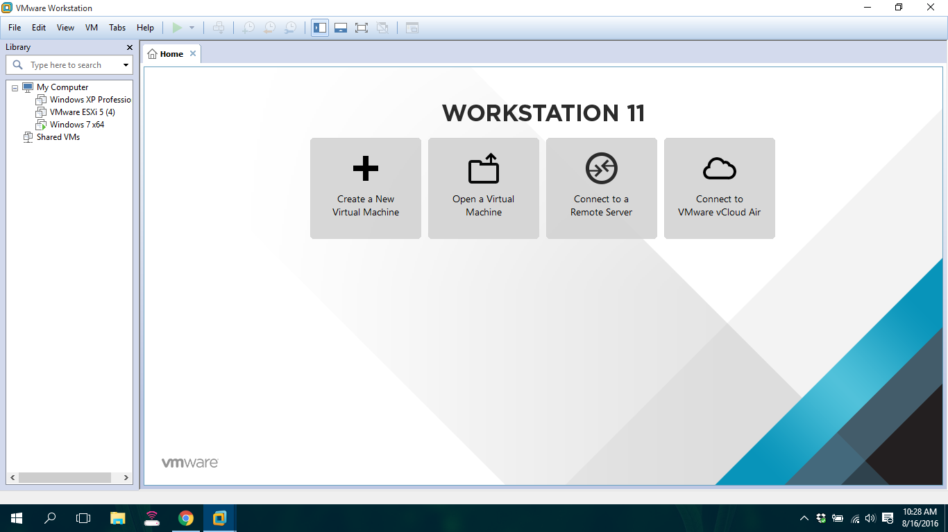

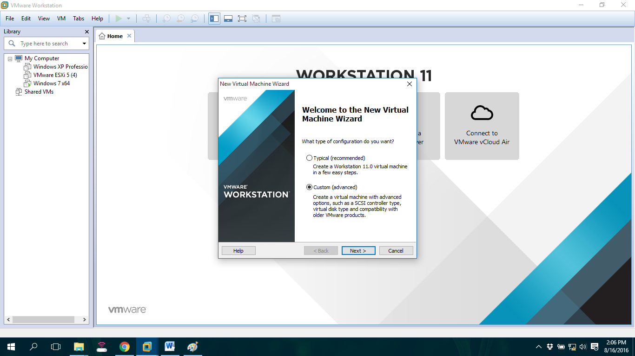

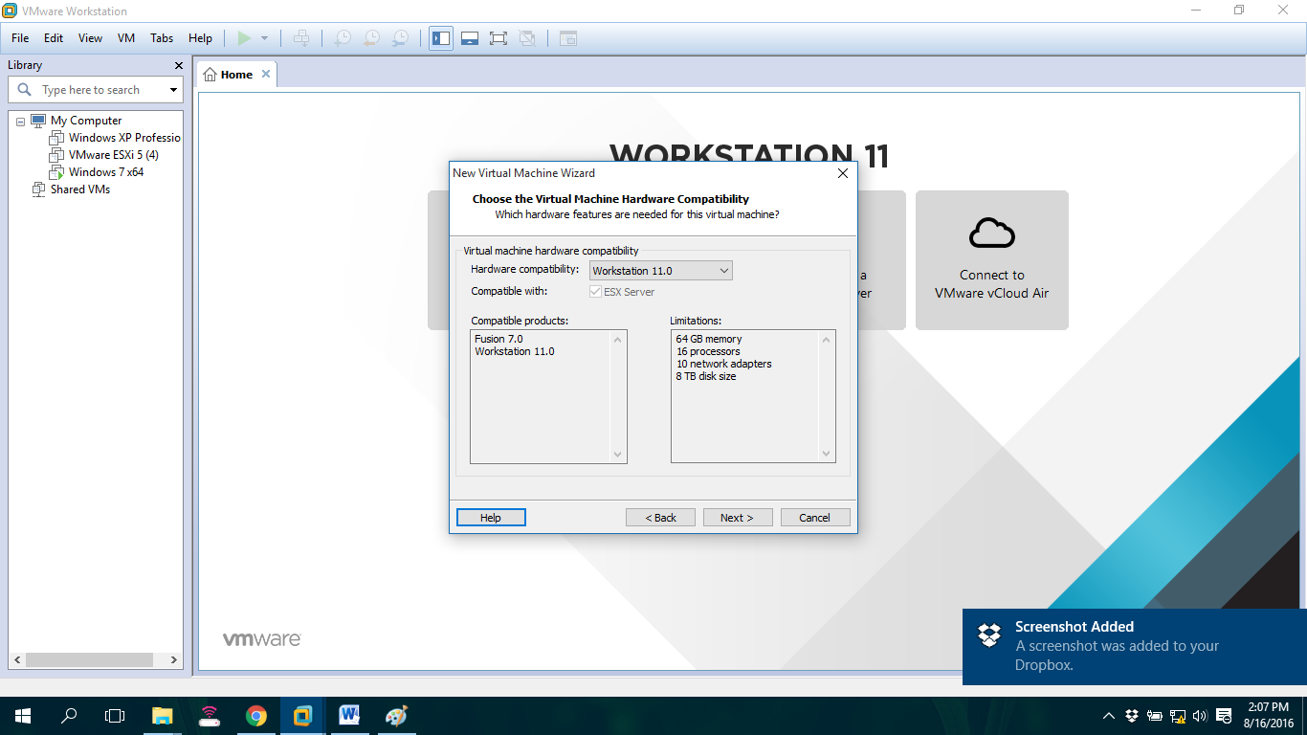

* Browse the iso file of VMware-VMvisor-Installer-5.5.0.update02-2068190.x86_64 .

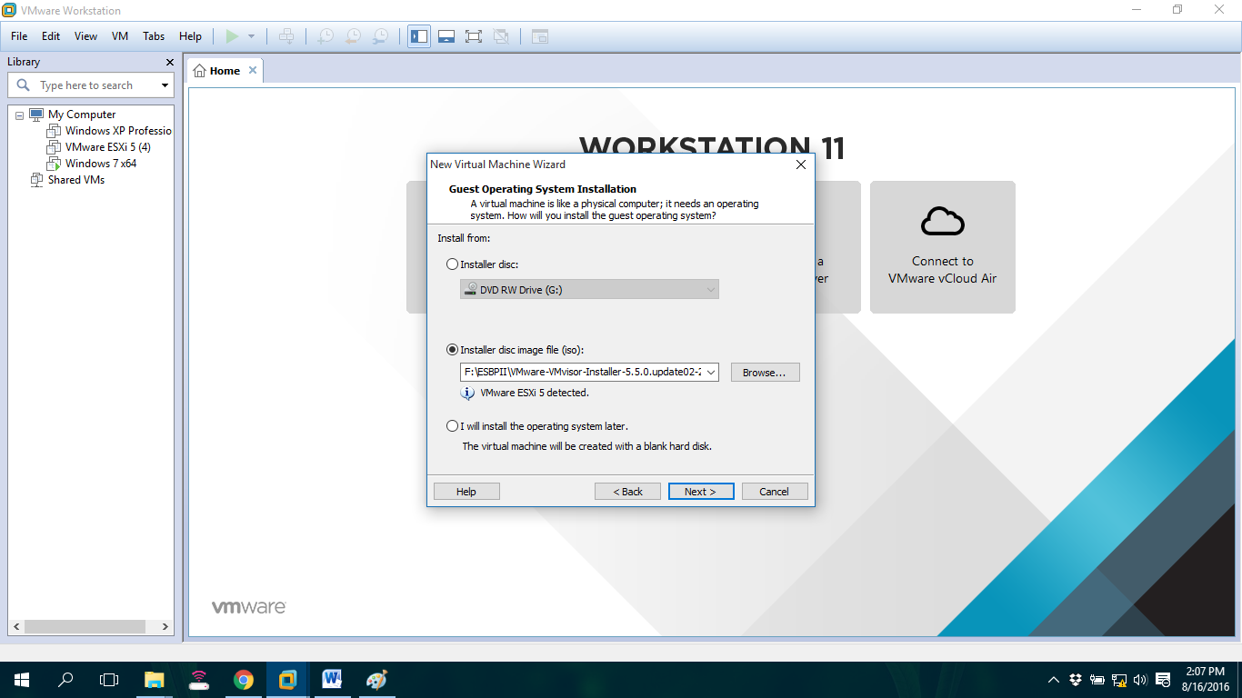

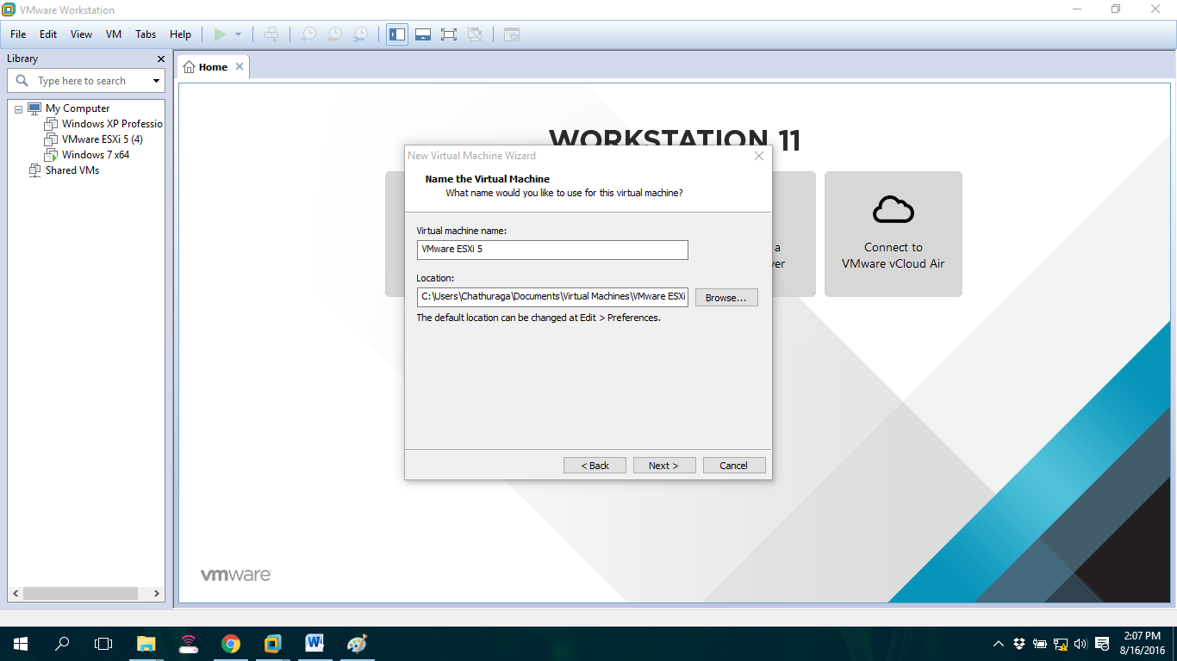

* Select necessary preferments.

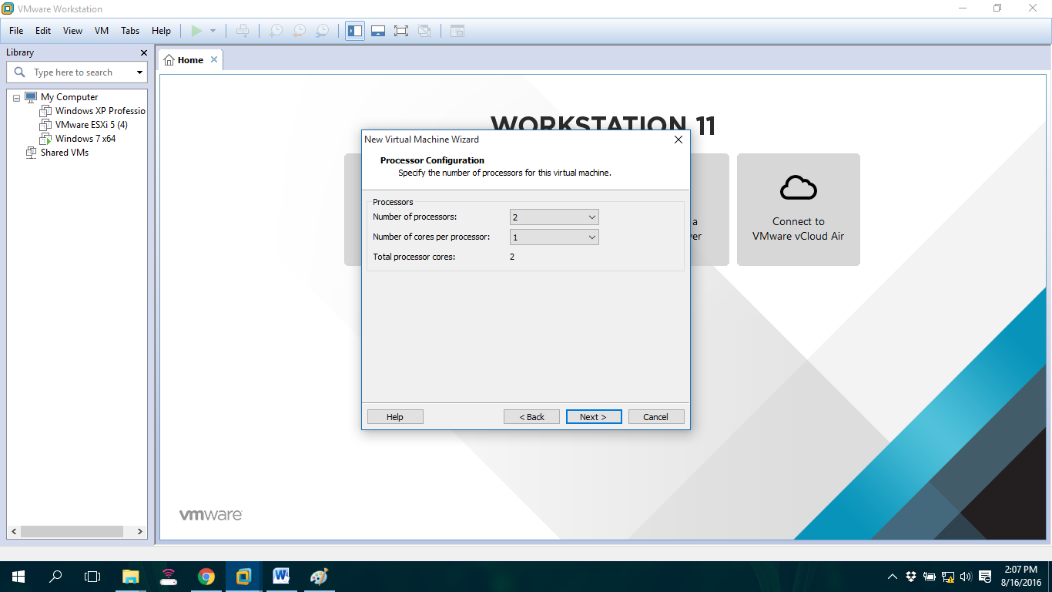

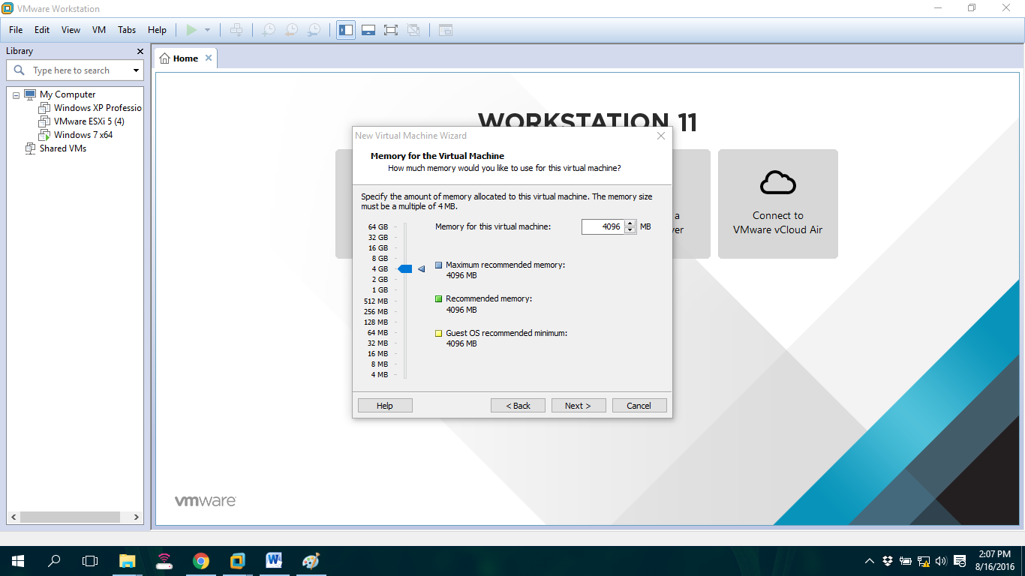

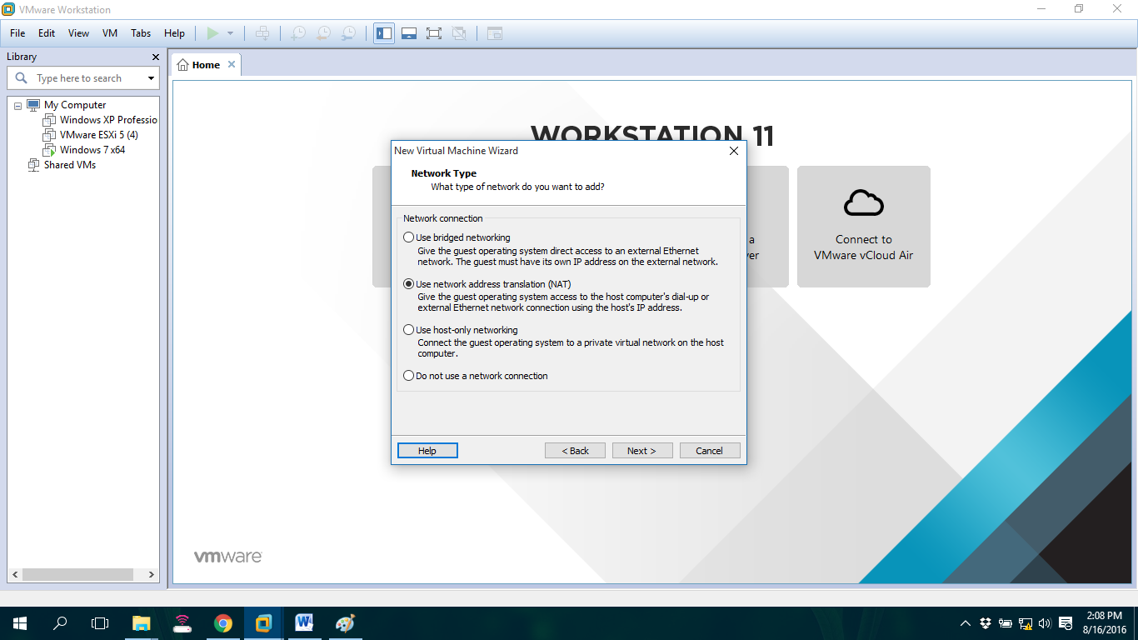

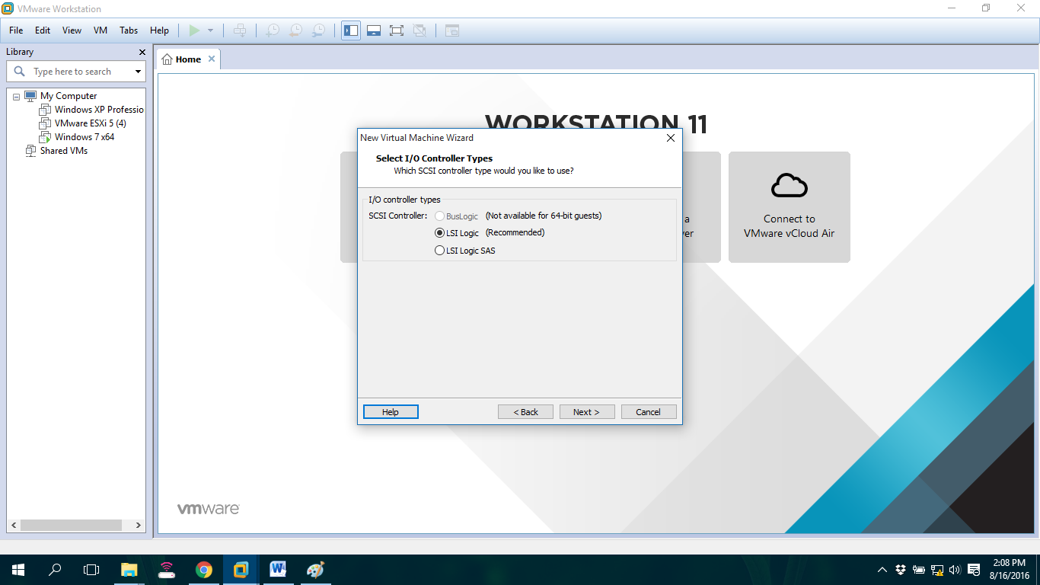

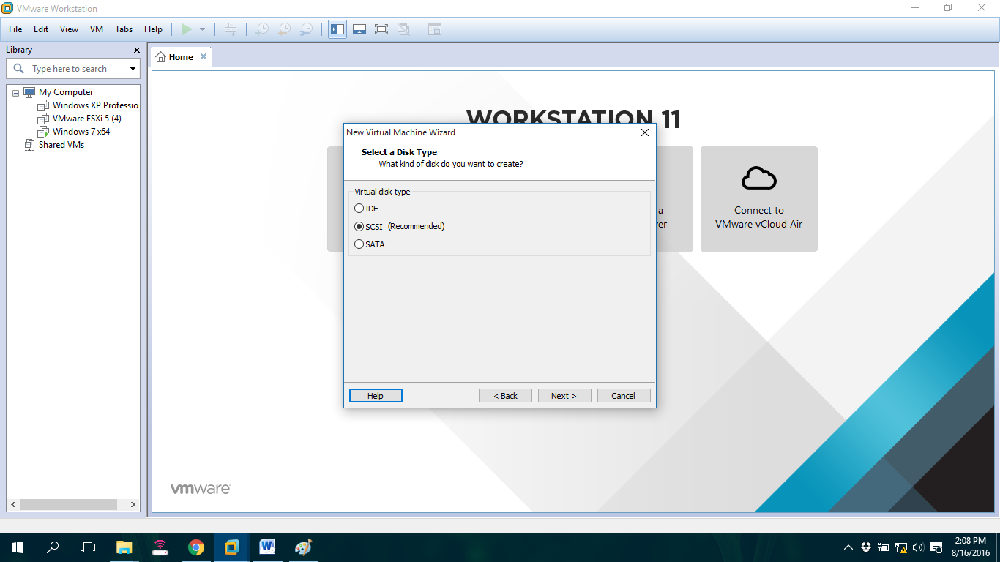

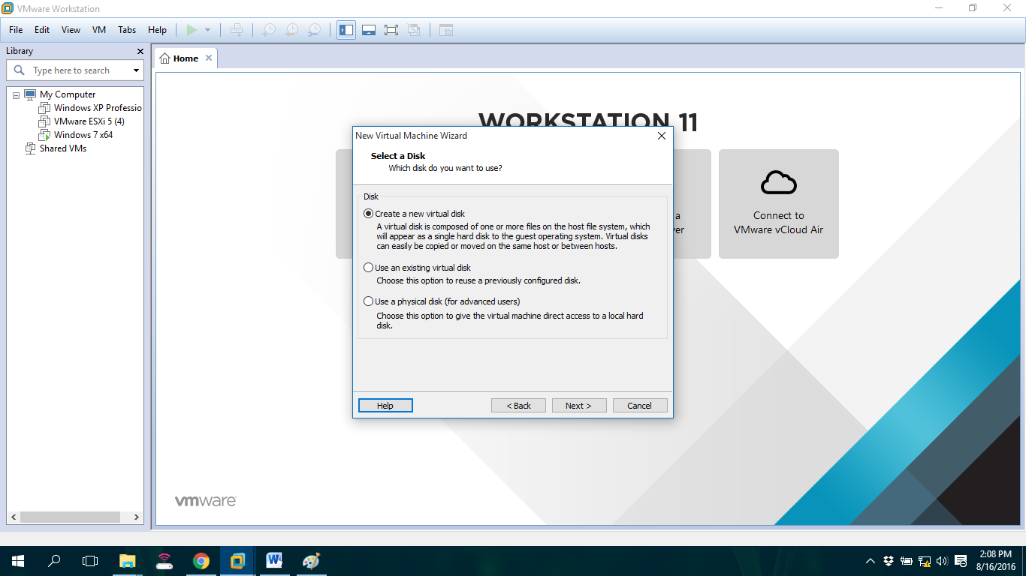

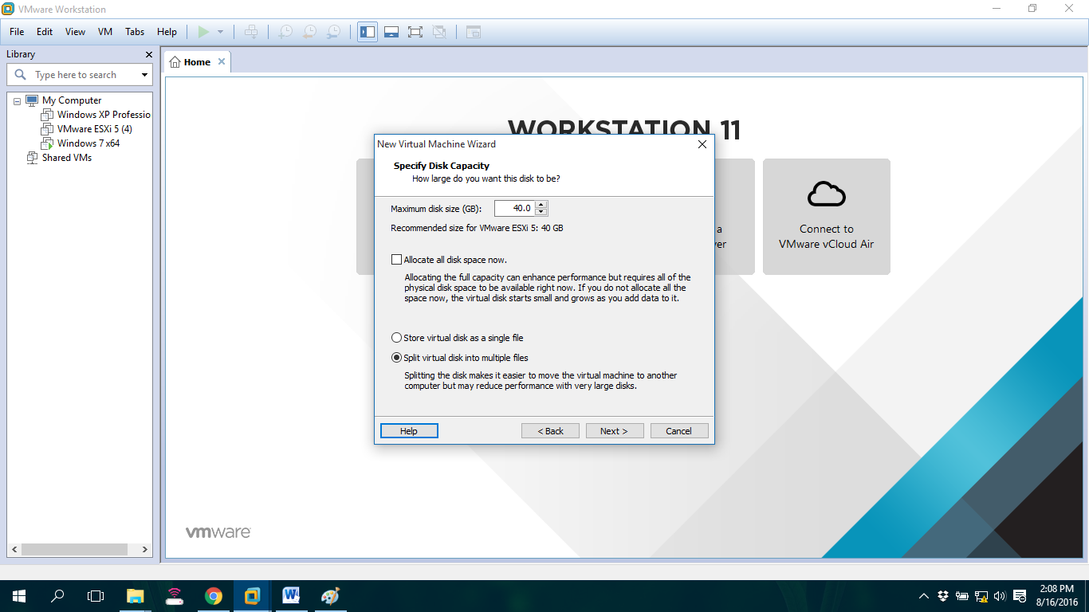

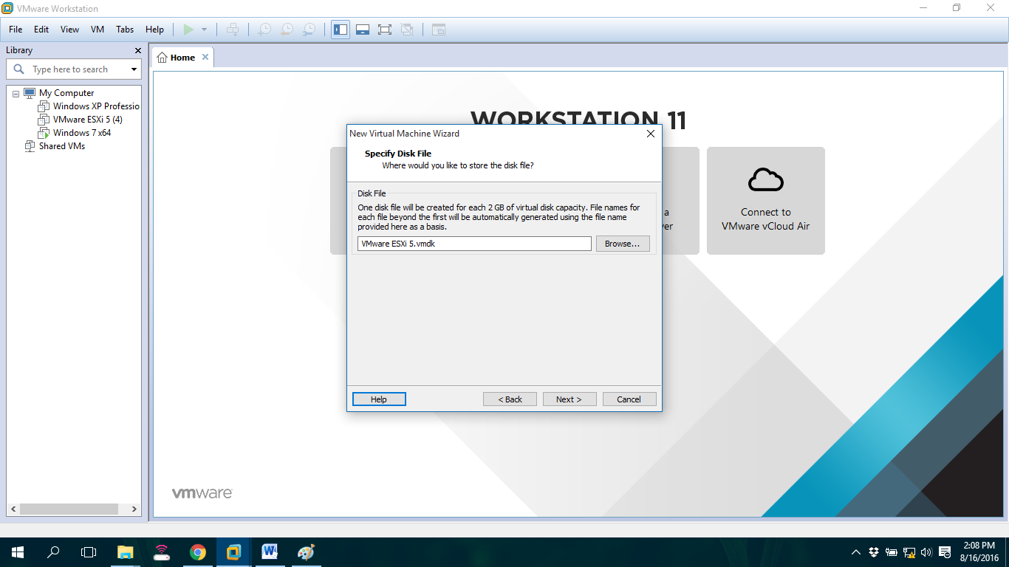

* Click Finish button to install VM.

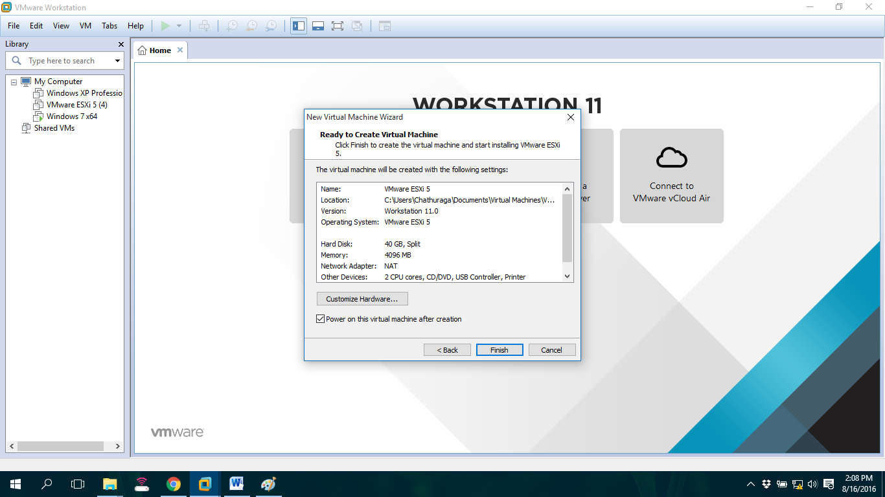

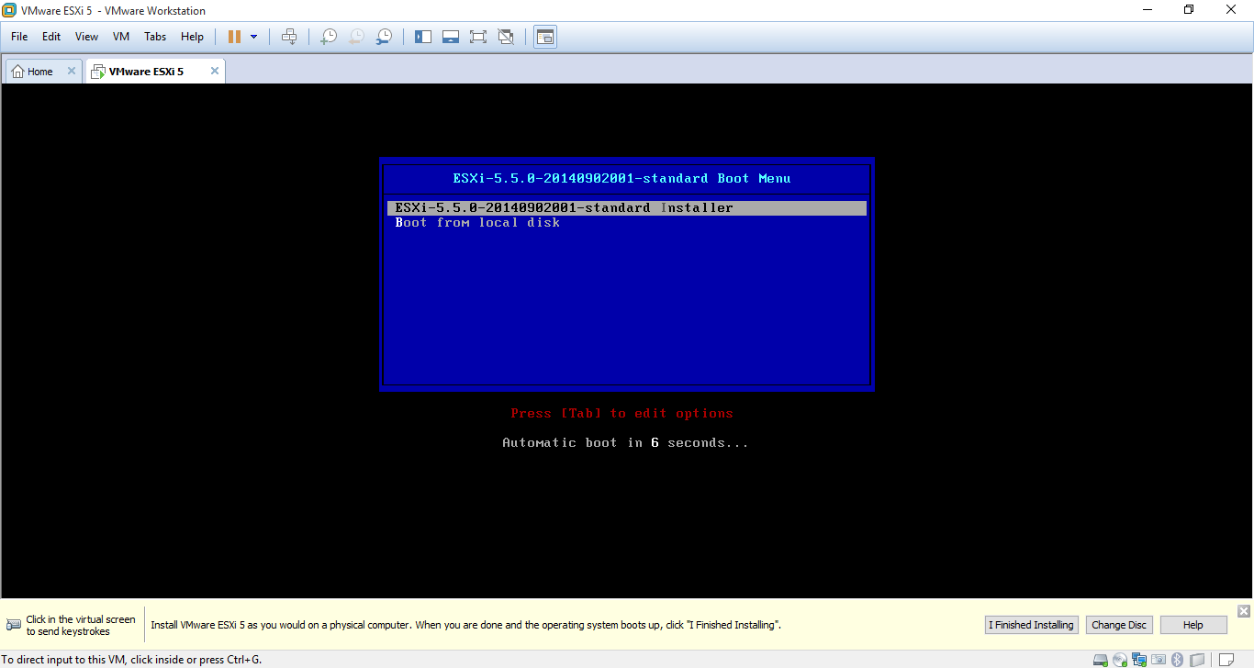

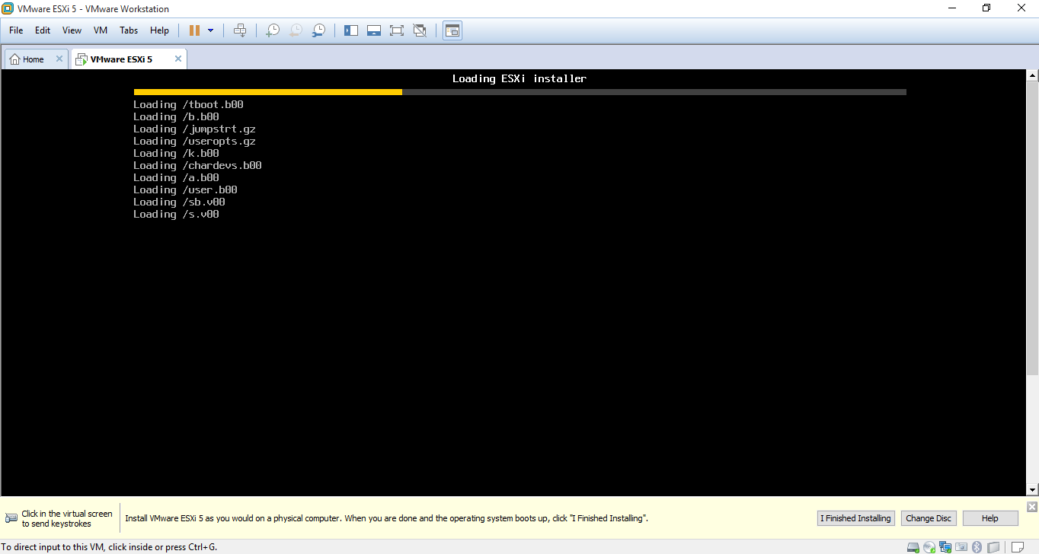

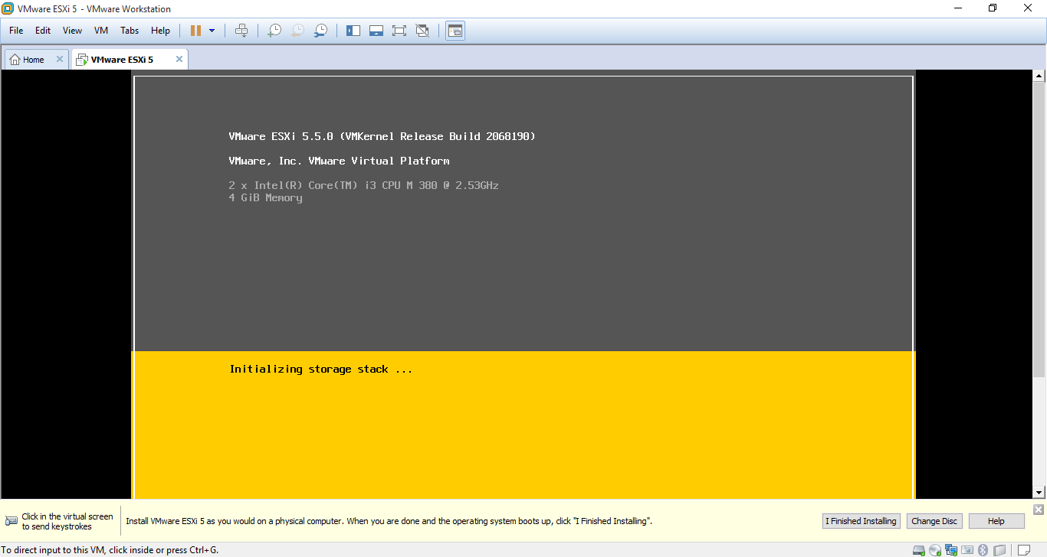

* Fallow the commands in message box.

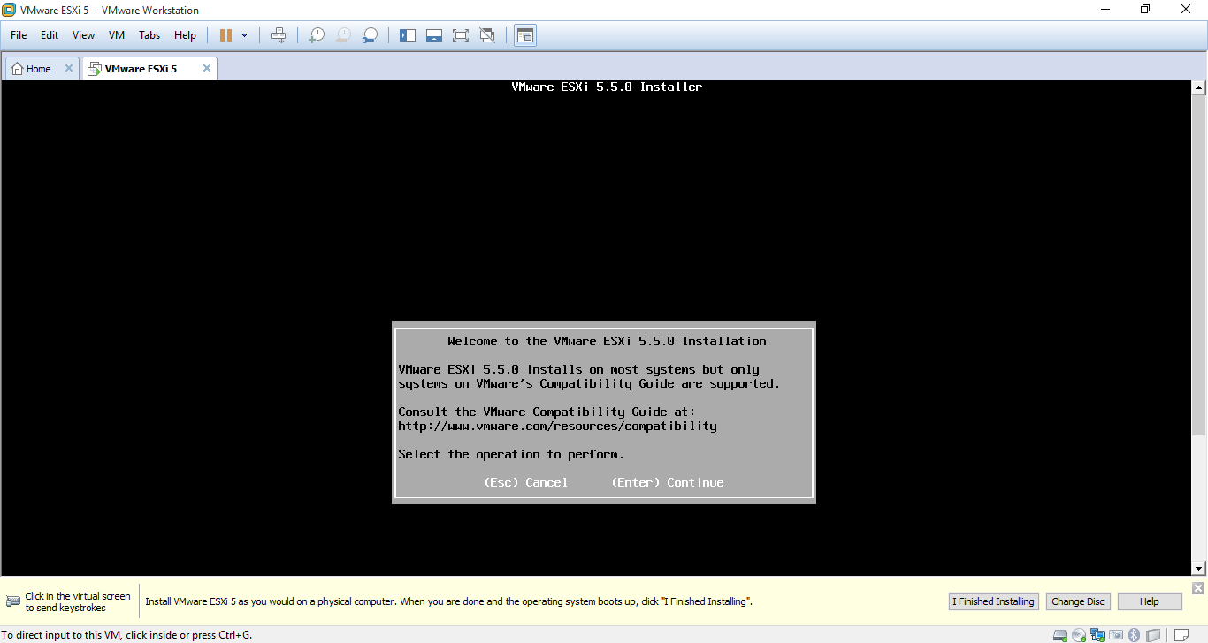

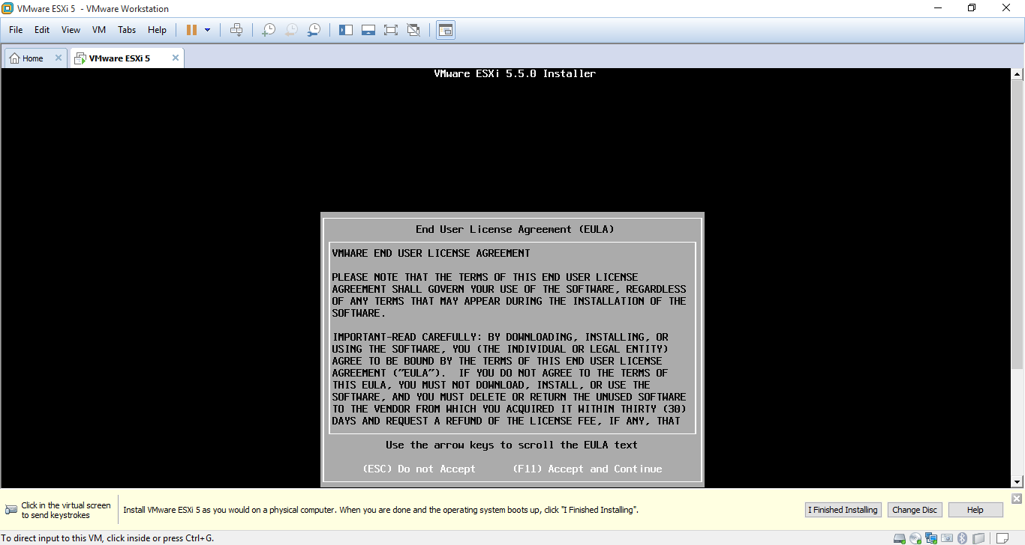

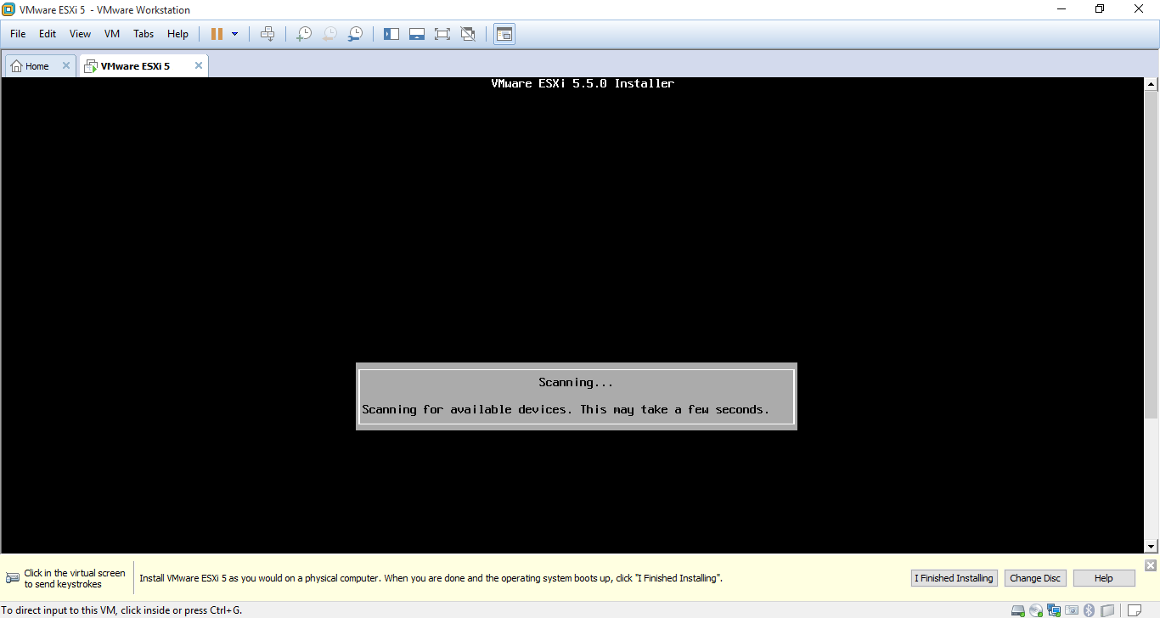

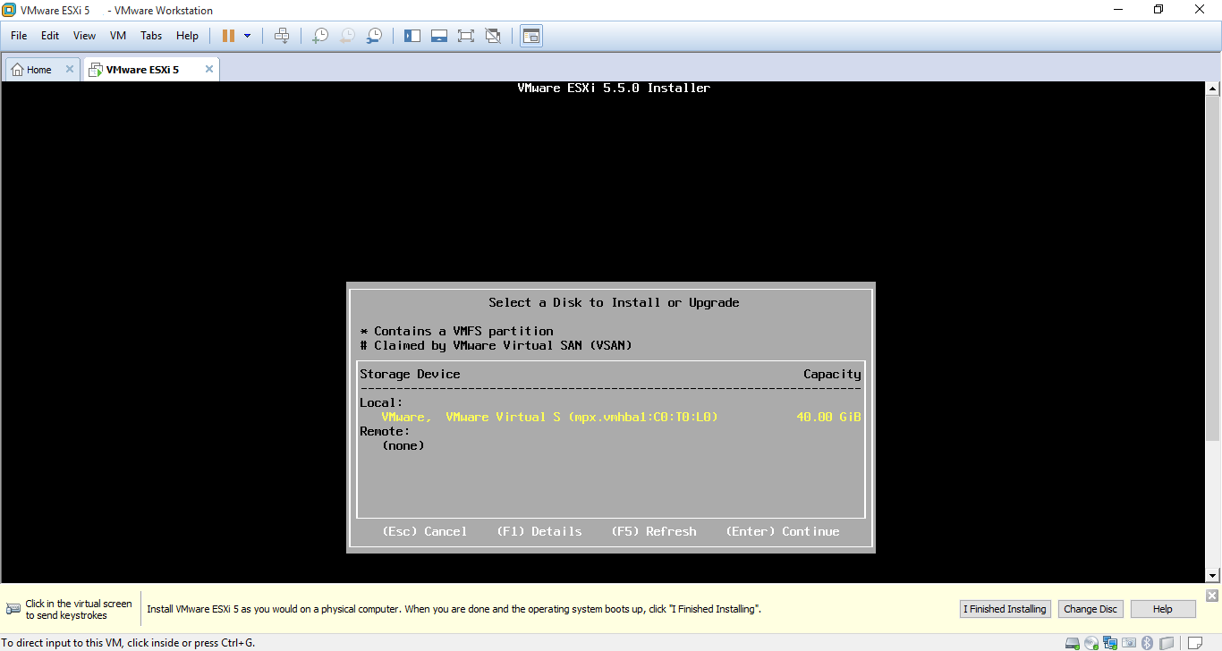

* Provide the necessary password.

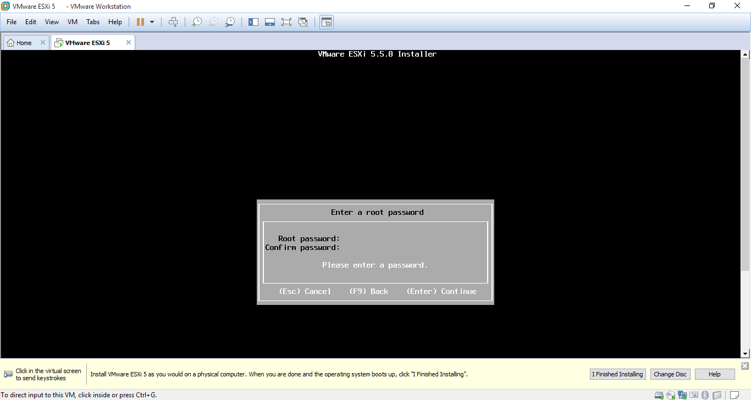

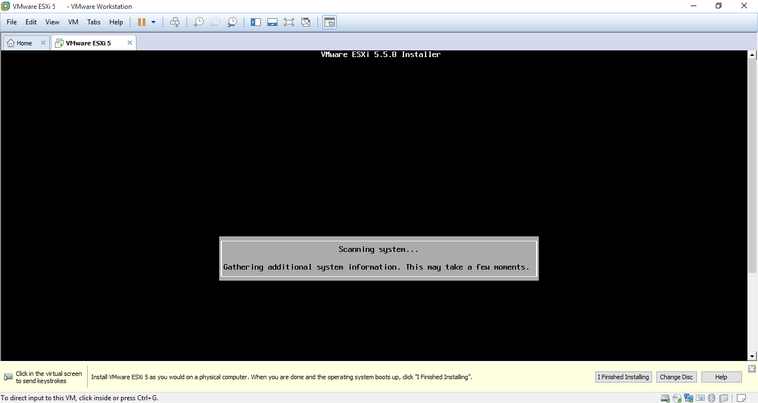

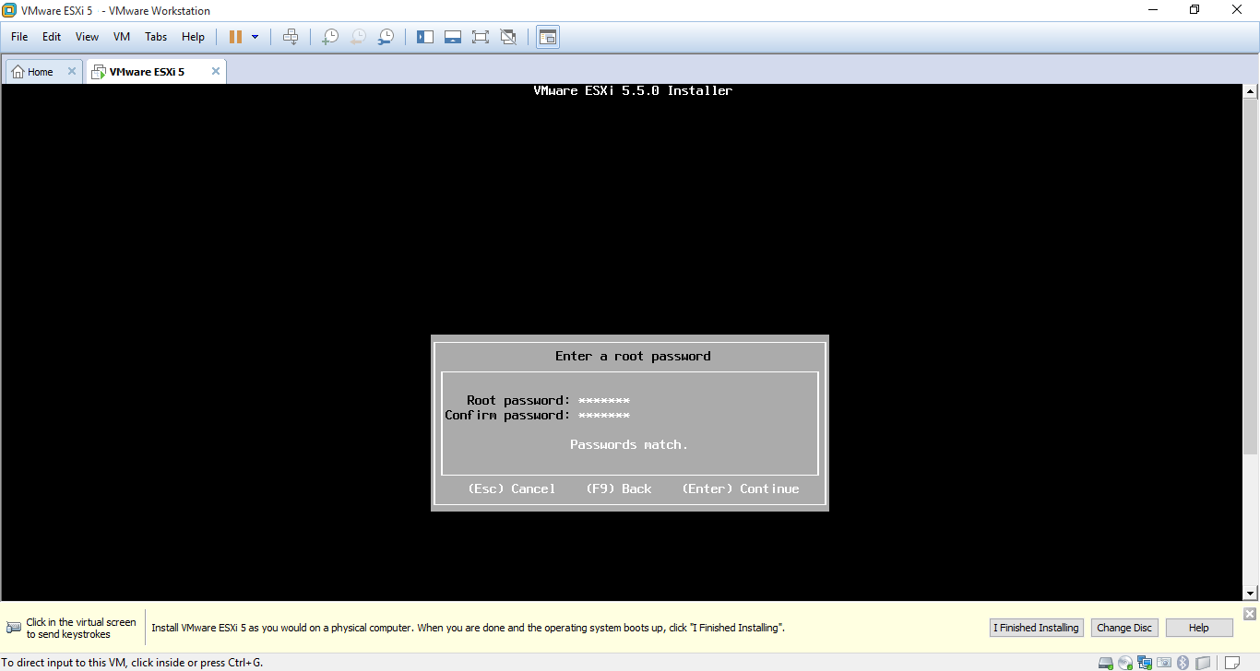

* Press F11 to install ESXi 5.5 hypervisor.

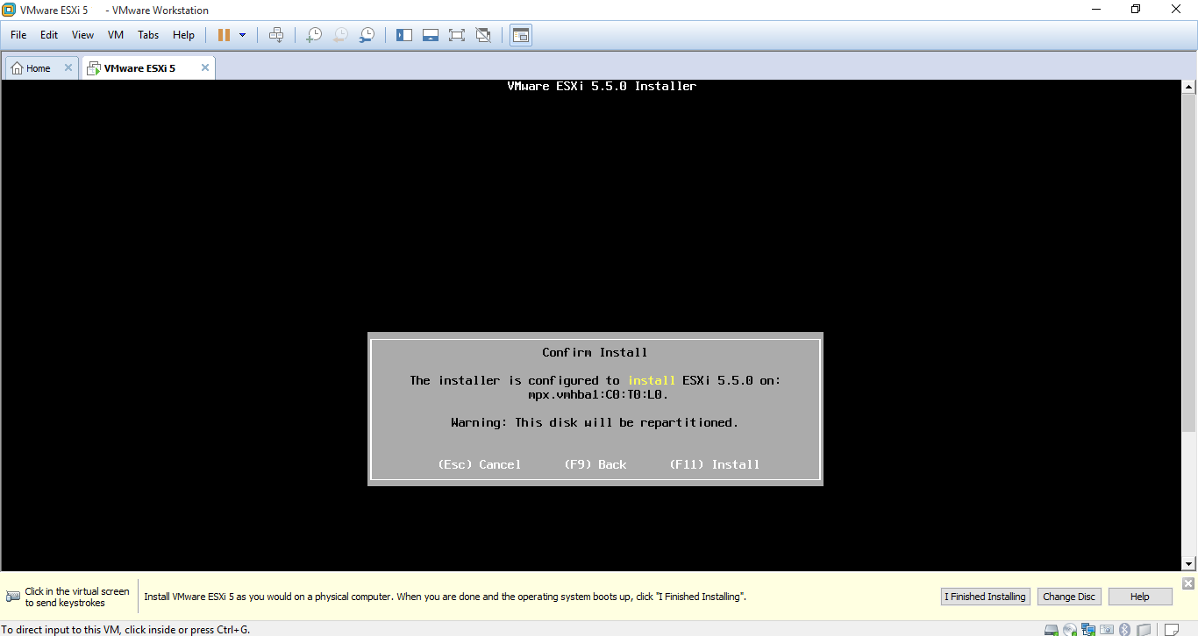

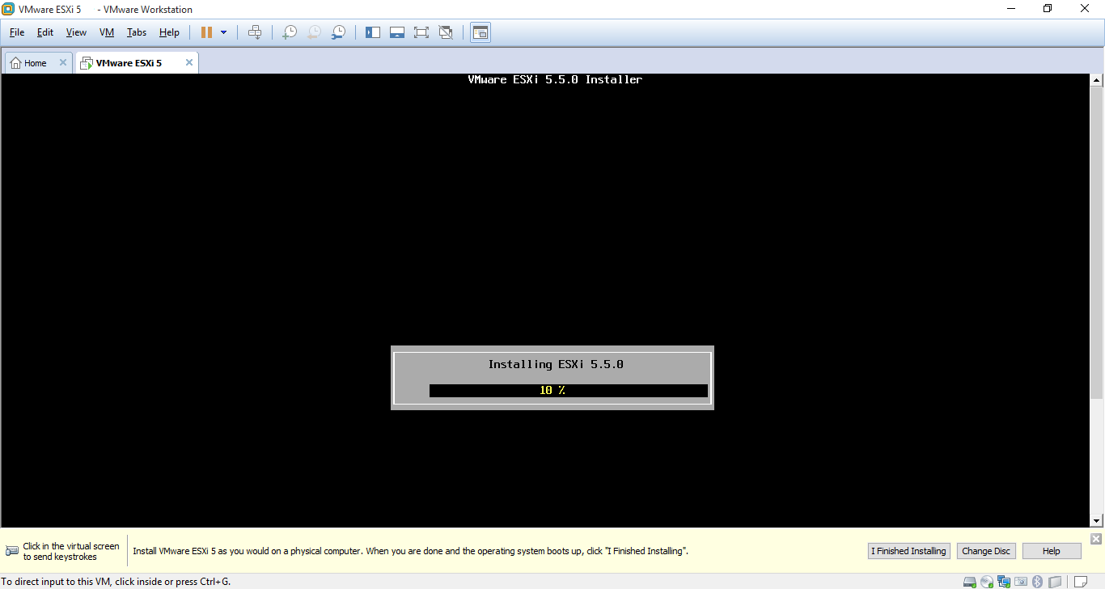

* When the successfully install the ESXi, Click Enter to reboot the VM.

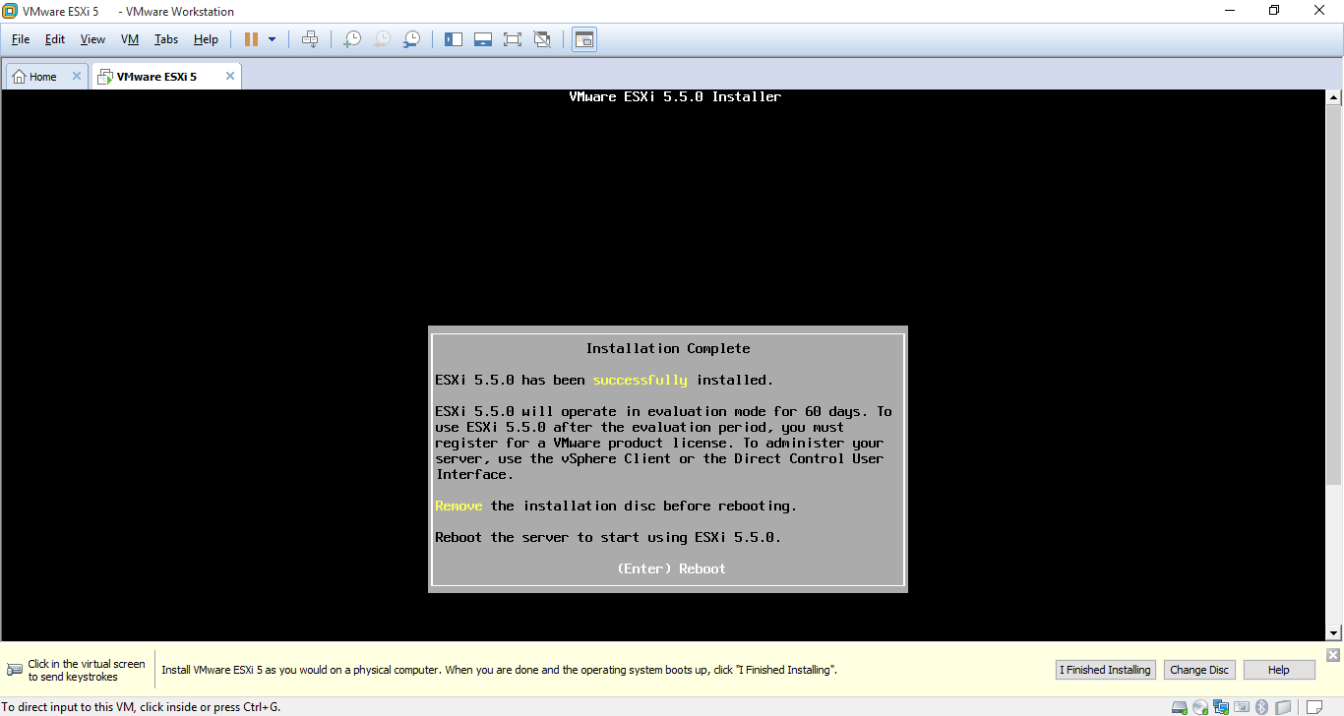

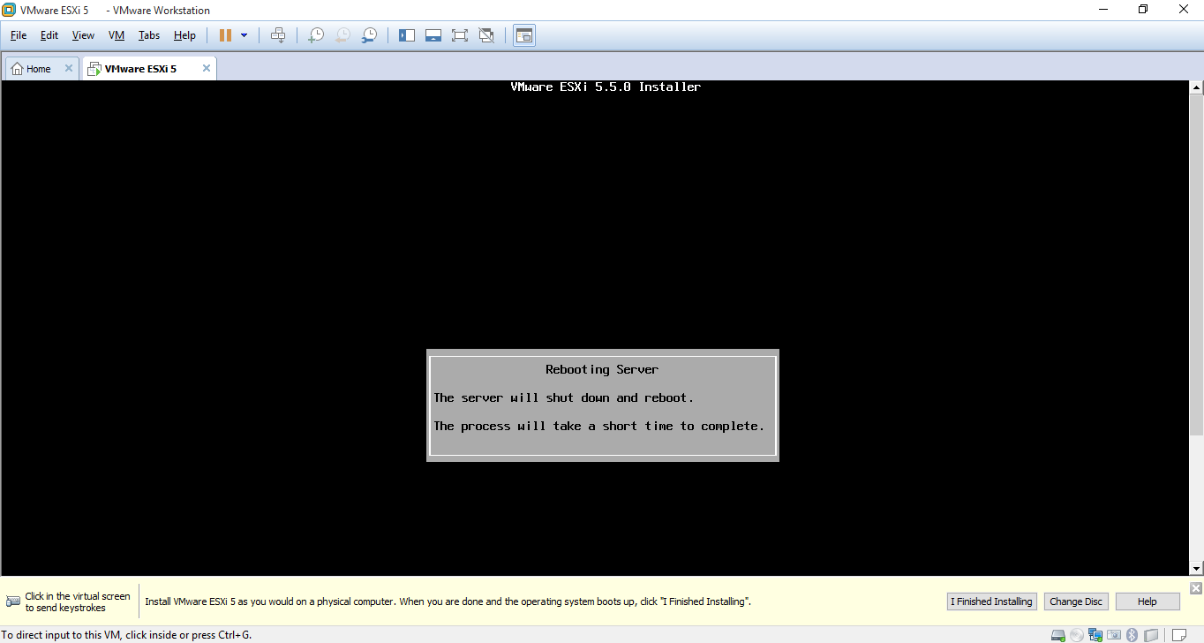

* After the restating the vm, we can get this window. It’s including links to download management tools.

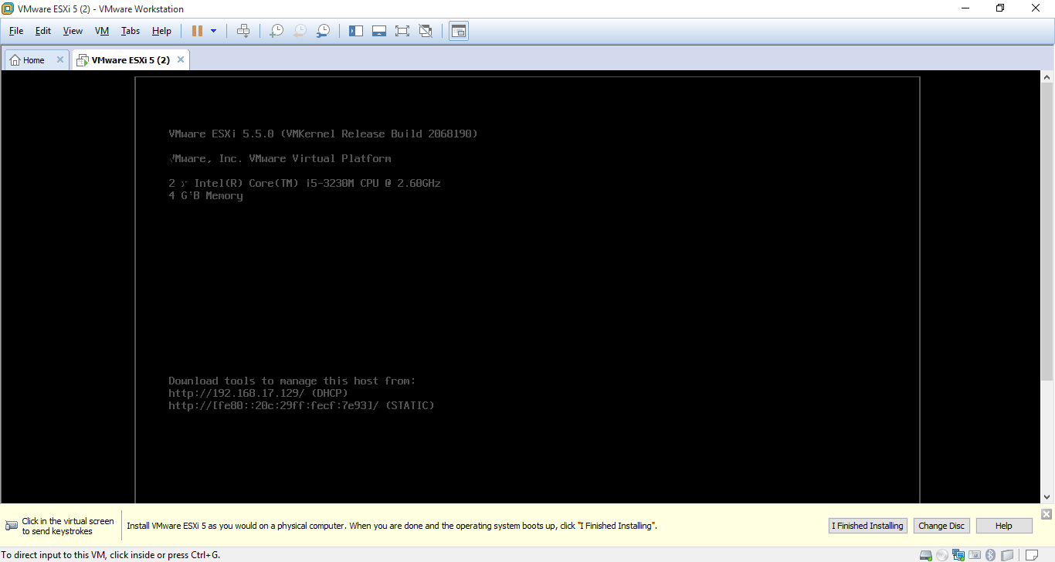

* Fallow that links and download VMware vSphere Client. Click Download vSphere Client.

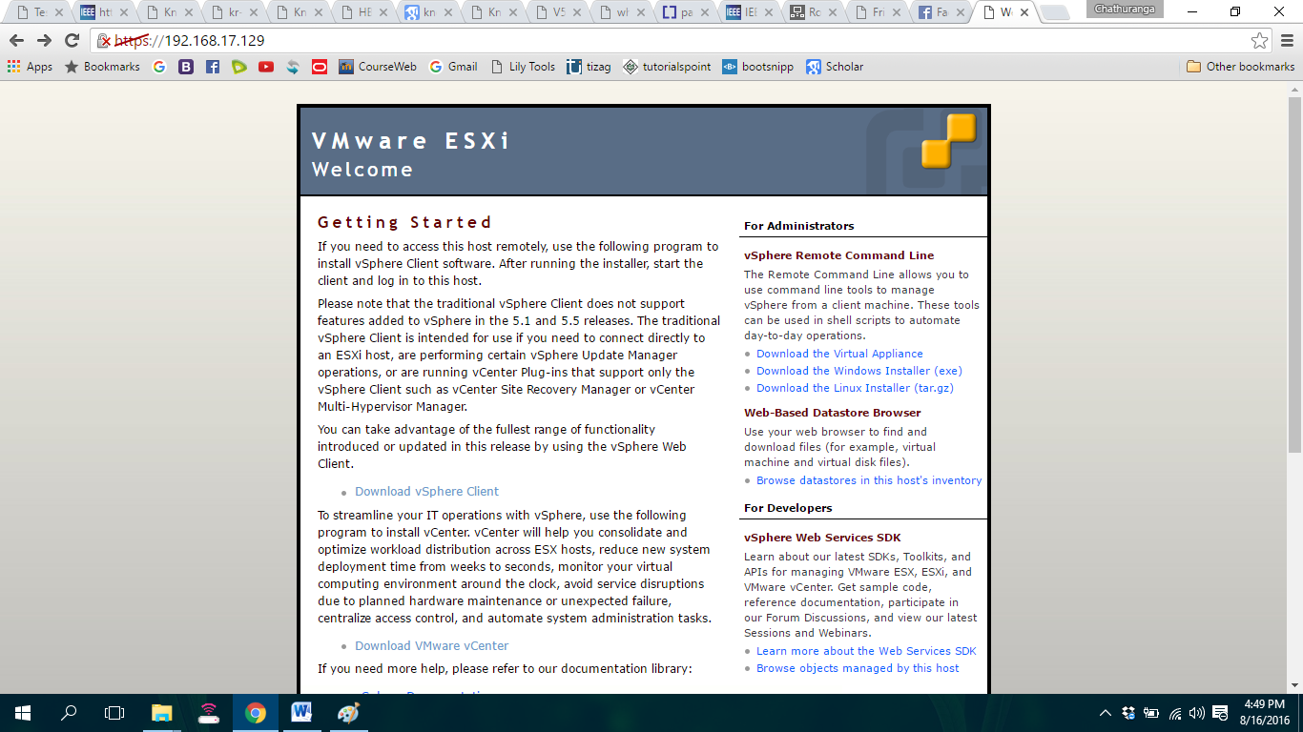

* Install the downloaded VMware-viclient-all-5.5.0-1993072 application.

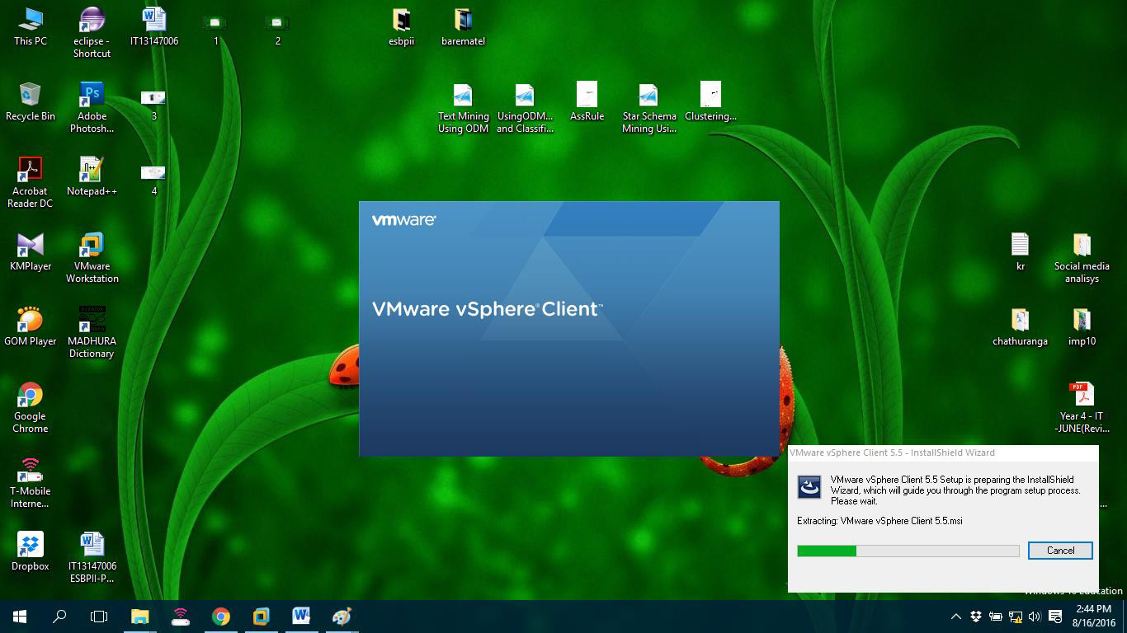

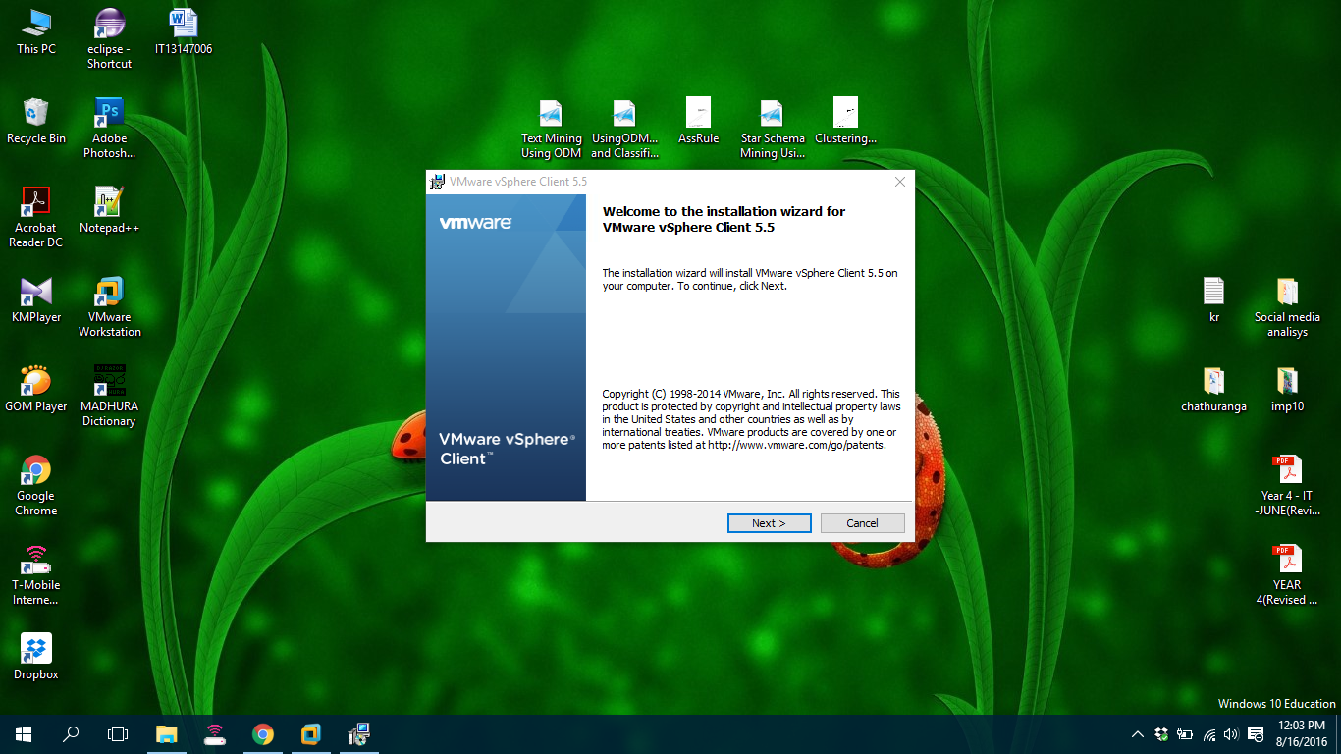

* Provide the host IP address, User name and password. click login button.

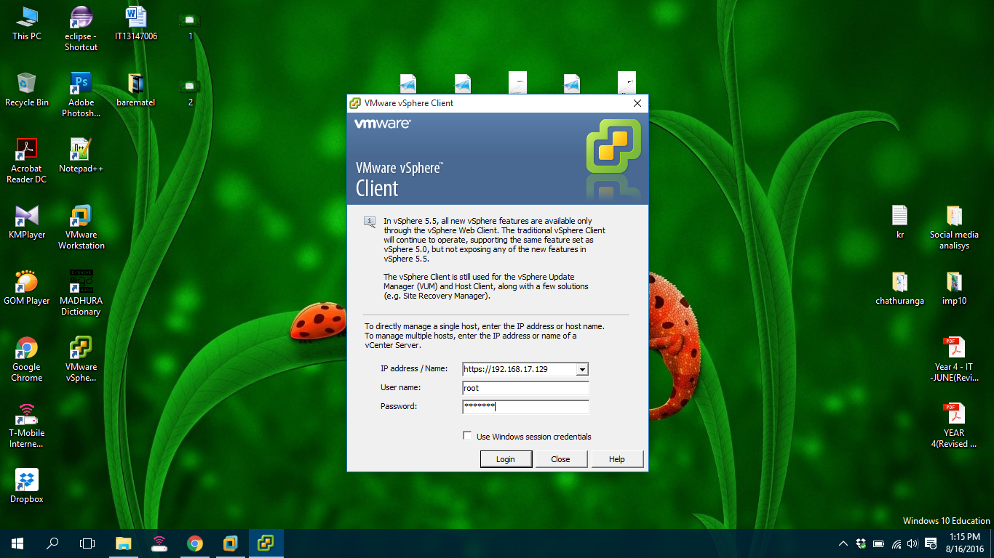

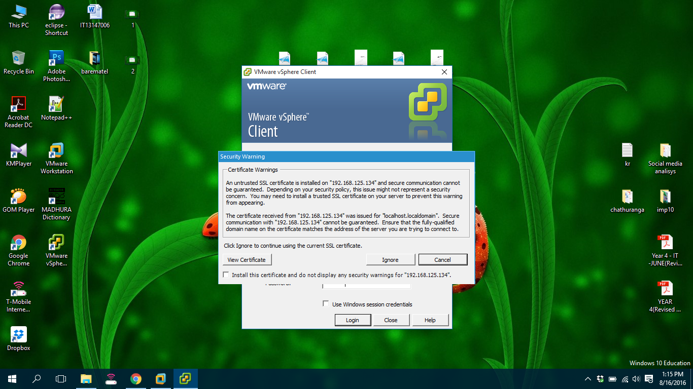

* Since the client and server in different in machines (operating systems) using the client machine we are going to install a new operating system for the server (which is in the virtual machine) using following configurations.

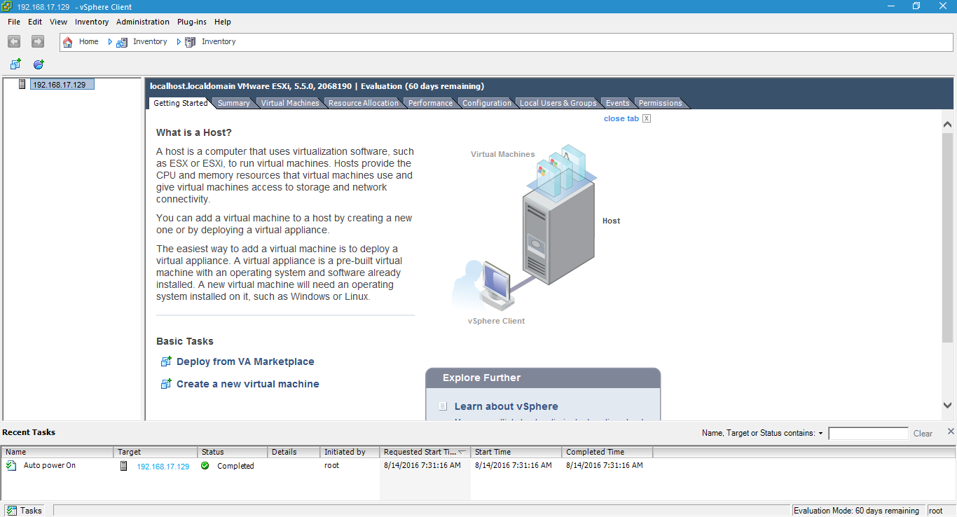

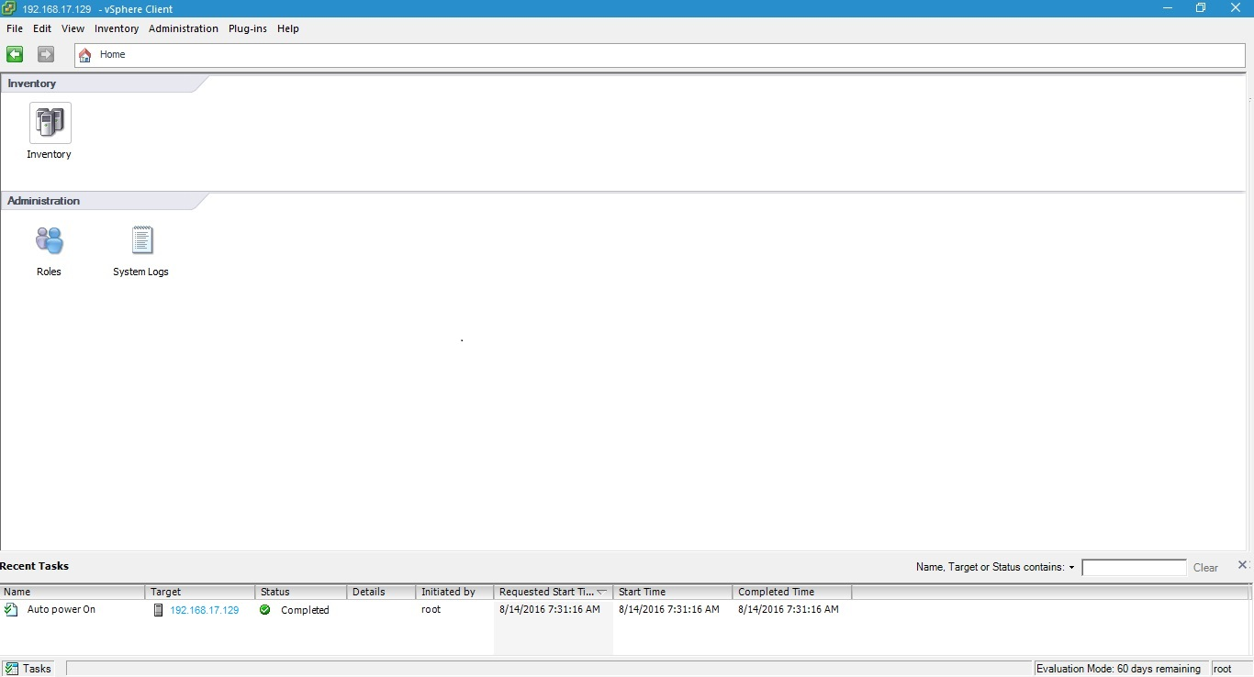

* Create new virtual machine of kali Linux

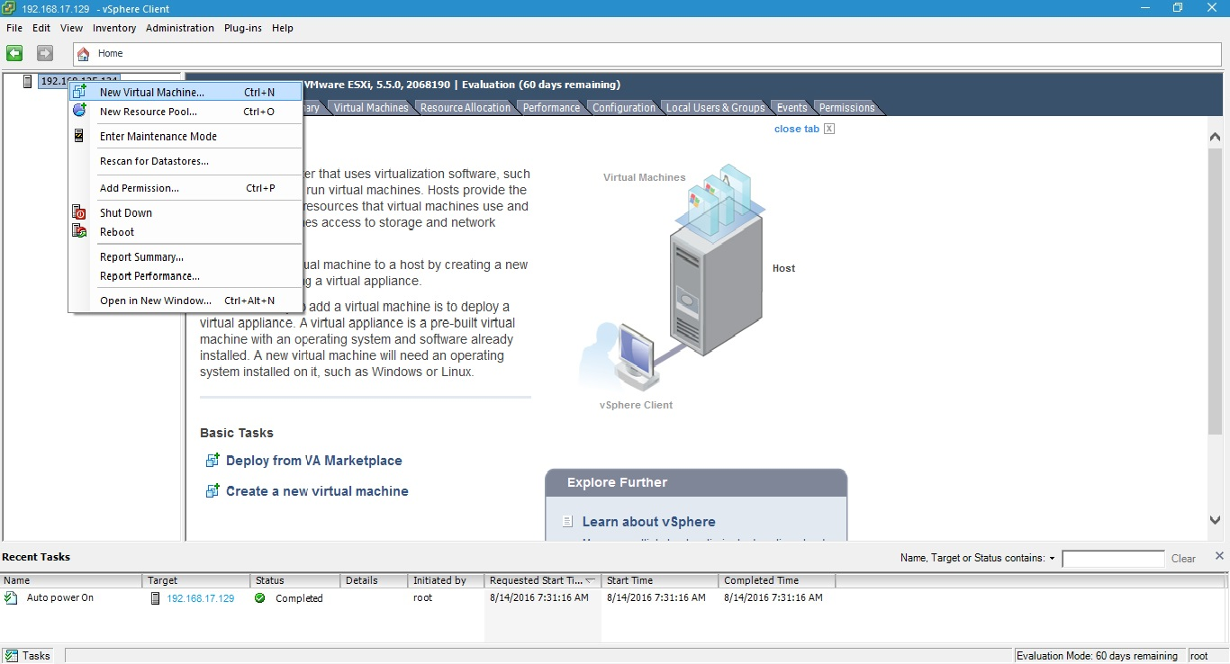

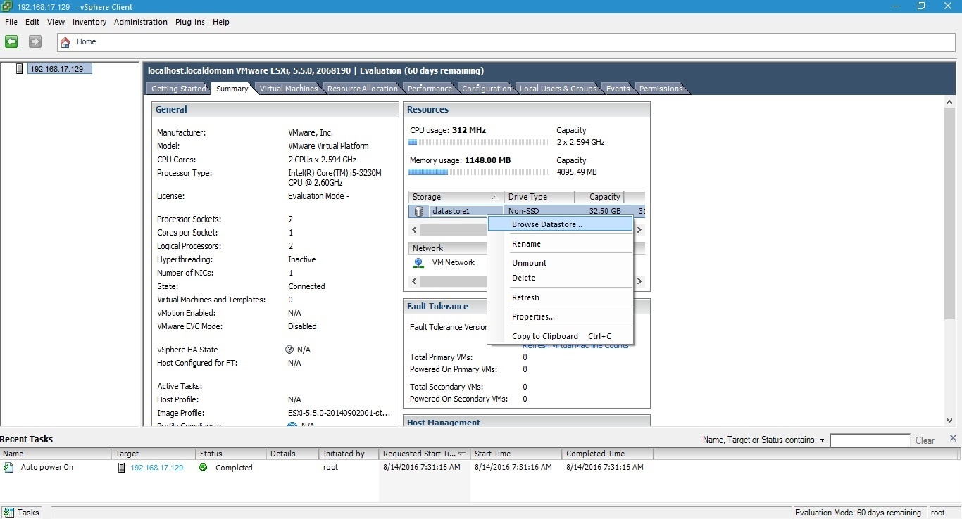

* Upload the iso file of Kali Linux

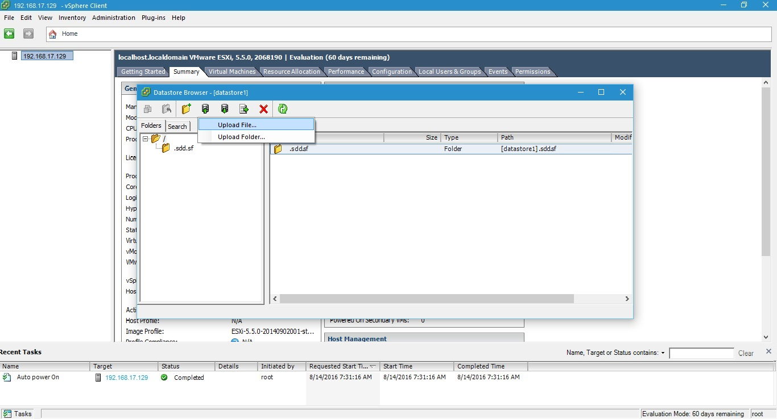

* Browse and select the iso file of Kali Linux

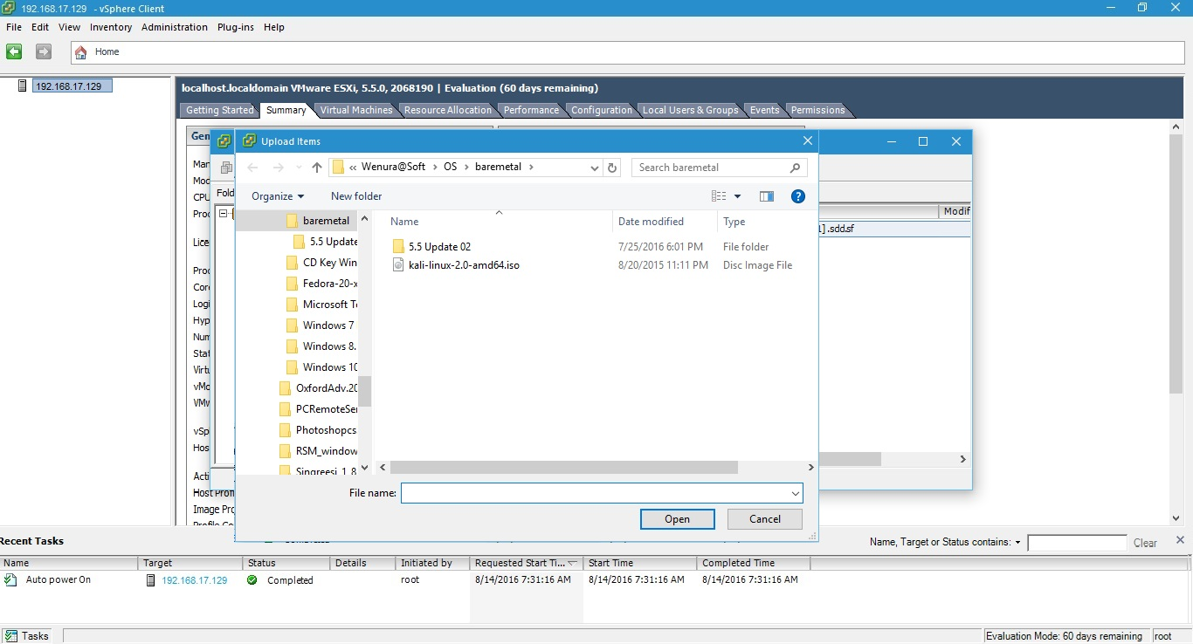

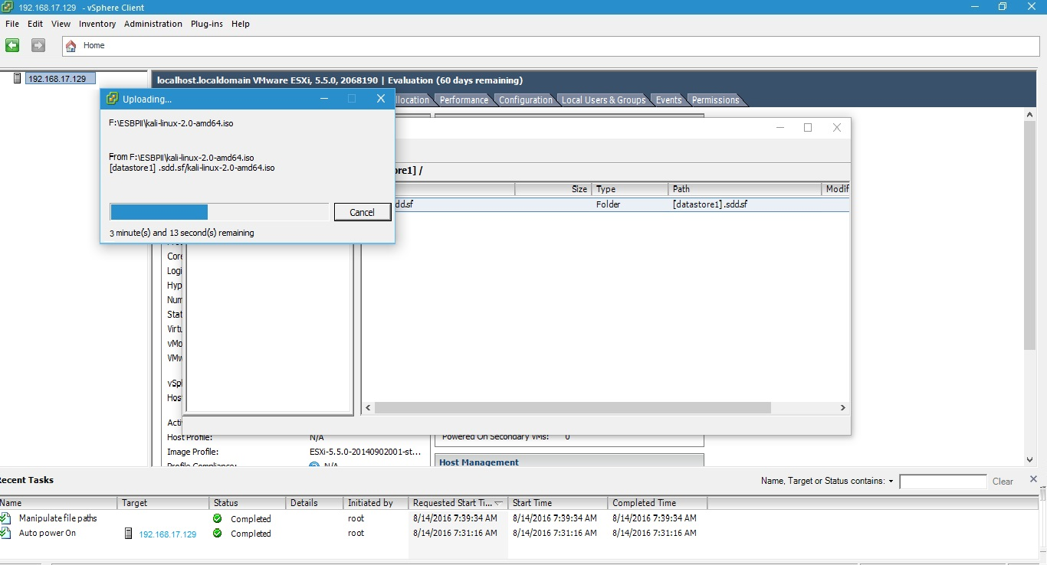

* Then in the next popup windows give the operating systems configurations as following images.

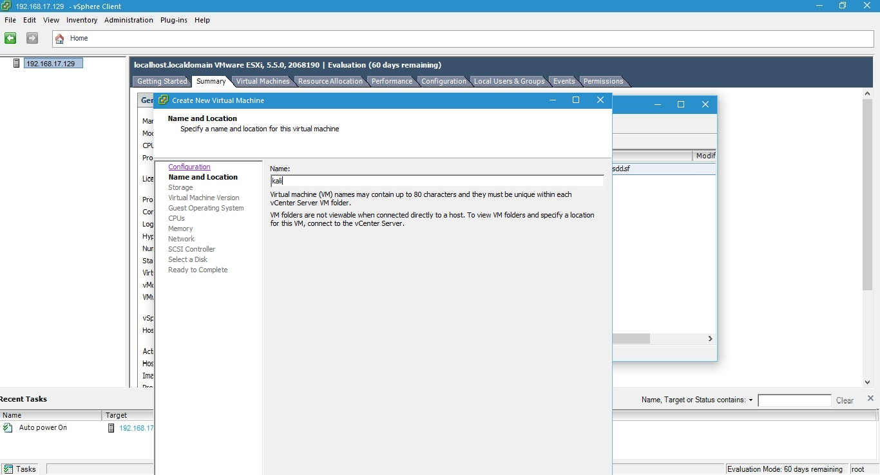

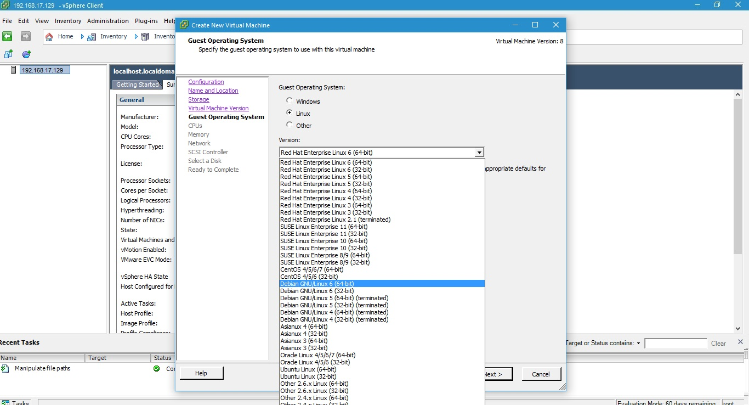

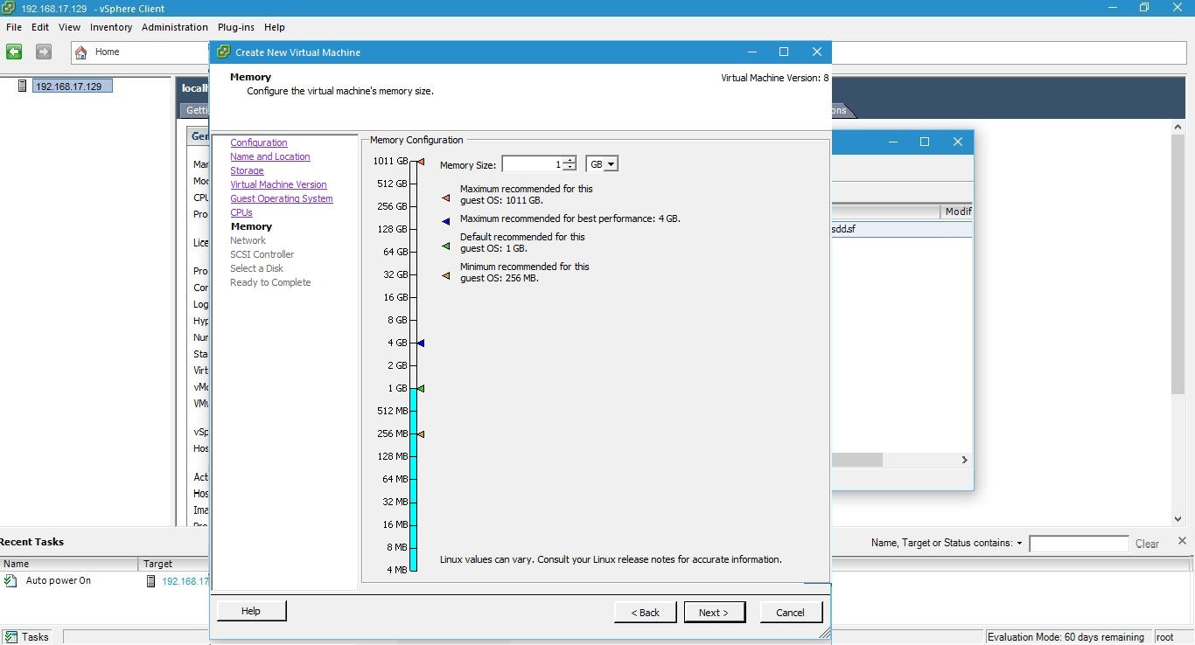

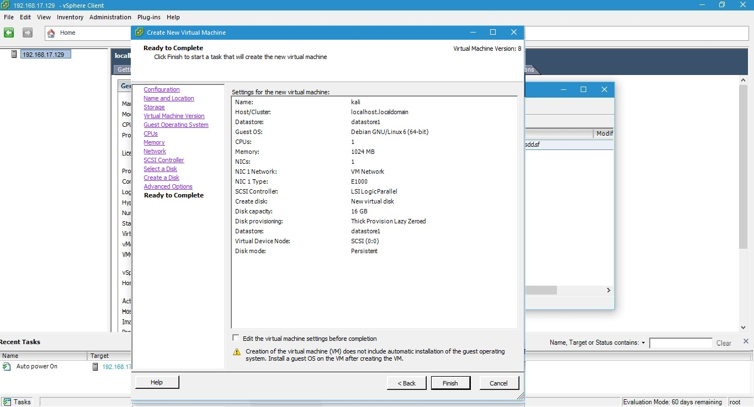

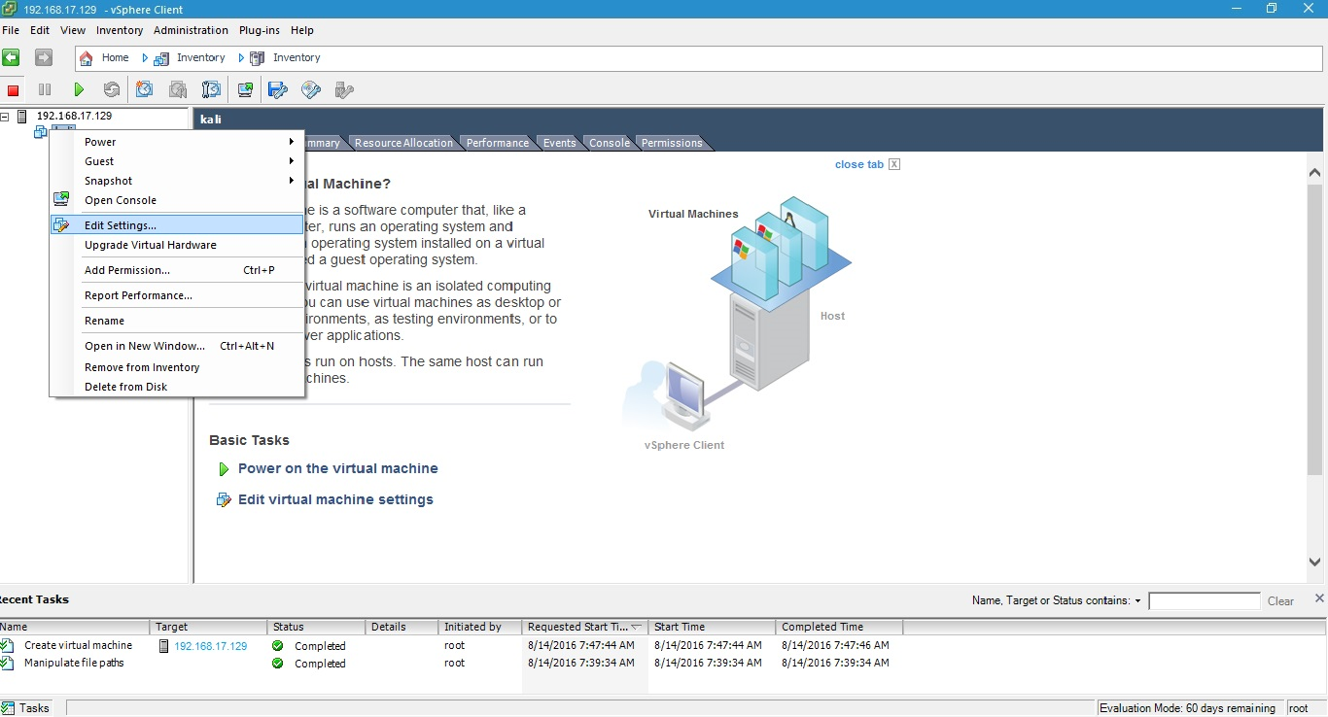

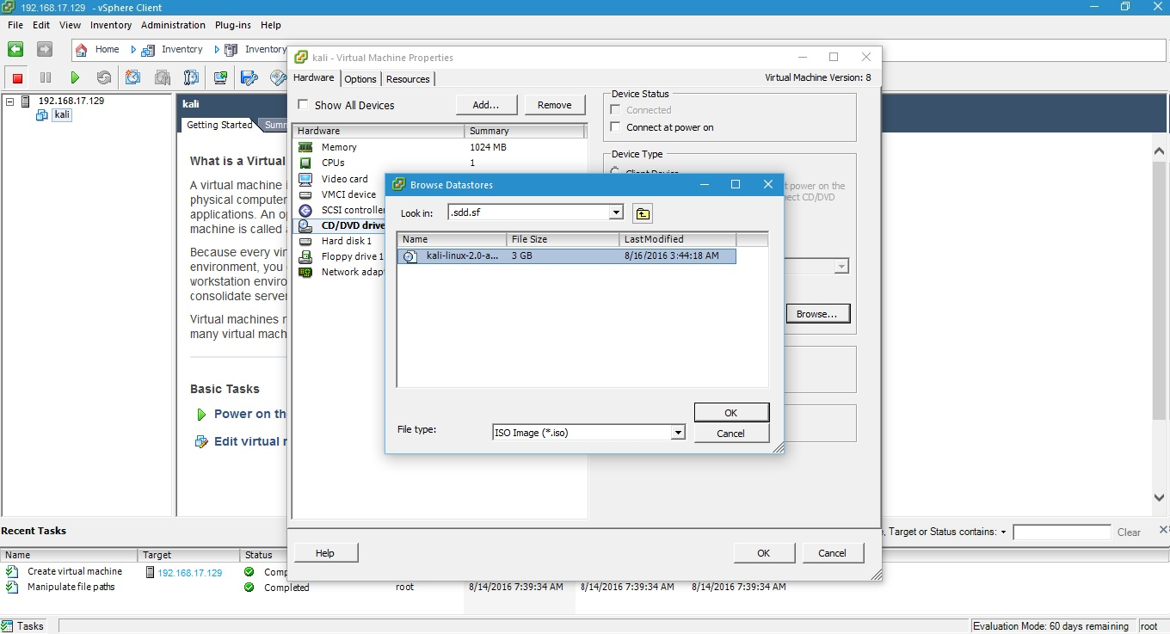

* Then power on the vm.

